FYI. Best, Munsup  
  
P.S. Please reply back to me with ‘unsubscribe’ added to the subject line if you no longer want to receive my e-Newsletters. The convenient link to unsubscribe is no longer available due to security reasons to protect my email servers.  
  
----------------------------------------------------------------------------------------------------------------------------------------------------

* FW: Happy New Year from the AAUP!
* FW: A heartfelt thanks from Consumer Reports
* FW: I Know You Know How This Is Done
* FW: Ice cream is awesome. This is disgusting.
* FW: What do you call somebody who supports Israel?
* FW: When it's okay to quit your new job

----------------------------------------------------------------------------------------------------------------------------------------------------

**From:** American Association of University   
**Subject:** Happy New Year from the AAUP!  
  
We wanted to take a moment to thank you for being a member of the AAUP and wish you a happy new year!   
  
Thanks to your support and activism, our fight for academic freedom, shared governance, and a voice for faculty will continue to be strong this coming year.

[](https://urldefense.proofpoint.com/v2/url?u=http-3A__click.actionnetwork.org_mpss_c_-2DgA_ni0YAA_t.2dr_84MPo6IgSRSSJxavPkFAqQ_h1_HE2UYZIDTZxfLuJ8qHDFiCs-2D2BqE-2D2B-2D2Bms3i5sE3r94zkLFcwQxqLfD-2D2FvBzei6vGka49GE8IbSsL9DQmtTGenAypAR8UEJv034O6ZvrfrhGpVr4FJtAjGYZolTF-2D2BzjUbIvxrNnZpI14QElDxk1nJ9UkTNNyBPwCEuEQXoLZObnLh8zATzCiMWrj6-2D2FzzY-2D2FyOAj7CeZl5l-2D2BMTp0Zt6ywu1eFzDbzj5A5VVG7y6AhdnBz93zFzI2x-2D2BG4st5rPH1AluKi92KodDsfQgn8iOoh0QiAgljAe0WCkcYT3ivCCtfGoW720MSNaxrnT0YVlVHxYdD3guDvb6kniVo0D0OHlsTtNxHeHMpdx2ob0GYKfL7Ob2EucuocokqUxrHP3rupAHcnI-2D2BH&d=DwMCaQ&c=3buyMx9JlH1z22L_G5pM28wz_Ru6WjhVHwo-vpeS0Gk&r=phCHWq7iFpti1PjJ3qfQTZXE0FtC3_TBq31Z0Pw2RTs&m=8mNPAGSYcRUfMseOy-RnuUk2tL7NOA_krXJr89dVT7U&s=6zPsb-rlnx08sr30j6-xzZFw0I-IYp5g0ceLJ2yKNu8&e=)

**From:** Marta Tellado; President and CEO, Consumer Reports  
**Subject:** A heartfelt thanks



Every day, I am grateful for the voices, the feedback, and the generosity of supporters like you who make our work at CR possible. As we say goodbye to 2017 and look forward to a bright year ahead, I want to thank you for all that you do to contribute to our mission and ensure that the products we use, the services we depend on, and the markets we enter are designed to put people’s interests first.   
  
Please don't hesitate to reach out to us at [**CRFeedback1@consumer.org**](mailto:CRFeedback1@consumer.org) if there is anything we can do to be a better partner to you in the year ahead. And on behalf of the CR team, best wishes for a healthy, happy new year.

**From:** Kathleen To  
**Subject:** I Know You Know How This Is Done  
  
WOW!  This is the ultimate talent!  
[Tony and Jordan: Identical Twins Dazzle With Magic - America's Got Talent 2017 - YouTube](https://nam01.safelinks.protection.outlook.com/?url=https%3A%2F%2Fwww.youtube.com%2Fembed%2FmYTNQhK5Cgk%3Frel%3D0%26start%3D043%26end%3D196%26fs%3D1%26showinfo%3D0%26modestbranding%3D1%26autohide%3D2%26iv_load_policy%3D3&data=02%7C01%7C%7Cca9a32dc66804ec1381708d550aa5a57%7C84df9e7fe9f640afb435aaaaaaaaaaaa%7C1%7C0%7C636503614943167993&sdata=W%2FvCL9KSgjkqOZB7HeE7LdCKvZ33NO8VTHpDUZc65UI%3D&reserved=0)

**From:** Ben & Jerry  
**Subject:** Ice cream is awesome. This is disgusting.  
  
This is Ben Cohen and Jerry Greenfield, but you probably know us better as Ben and Jerry, the ice cream guys.  
  
Back when we were running Ben & Jerry's, we'd spend our winters brewing up new flavors for the spring and summer ice cream rush, but these days we're preparing for something that, in these dark times, is even more mouthwatering—the biggest demonstration ever against Citizens United, one of the worst Supreme Court decisions in American history that opened the floodgates to money in politics.  
  
As we reflect on the past year of the Trump administration, including the recent passage of the GOP's terrible tax scam, one thing is very clear: Now more than ever, it's Big Money vs. the rest of us.  
  
**Which is why we've partnered with MoveOn to offer you a way to speak out against Big Money a thousand times over: by (totally legally) helping you stamp your dollar bills with the message "Stamp Money Out of Politics." And we want to make January 21—the anniversary of Citizens United—the biggest day of stamping ever. Will you join in?**[**Click here to chip in $15 or more to MoveOn and get your very own "Stamp Money Out of Politics" self-inking rubber stamp. One lucky stamper will even win free Ben & Jerry's ice cream for a full year!**](https://act.moveon.org/donate/stamp-stampede-2018?suggested_ask=25&product_265=1&prefill=1&t=13&akid=196514%2E1195276%2EWZC5JK)Each marked bill is on average viewed 875 times, and this is a protest that will live on because the stamped bills stay in circulation for two and a half years. Already, nearly 3,300 people have pledged to stamp over 1.4 million bills in the week leading up to January 21. We're aiming to have 2 million bills stamped, which is why we need your help.  
  
As we face another year with Trump in the White House, it is now more important than ever before that we stand up for (and stamp!) our beliefs, visibly and often.  
  
Because the reality is that getting Big Money out of politics is the first step to achieving so much of our progressive agenda.  
  
Because it's Big Money that wrote that outrageous tax bill. It's Big Money that's behind opening up the Arctic National Wildlife Refuge to oil drilling. Big Money tried to kick tens of millions of Americans off of health care. Big Money just rolled back Net Neutrality.  
  
**Big Money needs to get out of politics. Can you help us make this message reverberate more powerfully than ever before? Chip in $15 or more to MoveOn now to receive your stamp and join the movement! You must order by January 10 to have your stamp delivered on time for our big day of stamping on January 21.**Don't forget, stamped bills get seen hundreds of times, and who knows who might see them—maybe a member of Congress or even a certain someone in the White House! Can you imagine how that would play out?   
  
[**Click here now to chip in $15 or more to MoveOn, get your stamp, and be entered in the contest to win a year's supply of delicious ice cream!**](https://act.moveon.org/donate/stamp-stampede-2018?suggested_ask=25&product_265=1&prefill=1&t=14&akid=196514%2E1195276%2EWZC5JK)Now, if you'll excuse us, we're going to go grab some ice cream—and then we've got some stamping to do.  
  
P.S. Here's a picture of what a dollar bill looks like after it's stamped! Cool, right?

[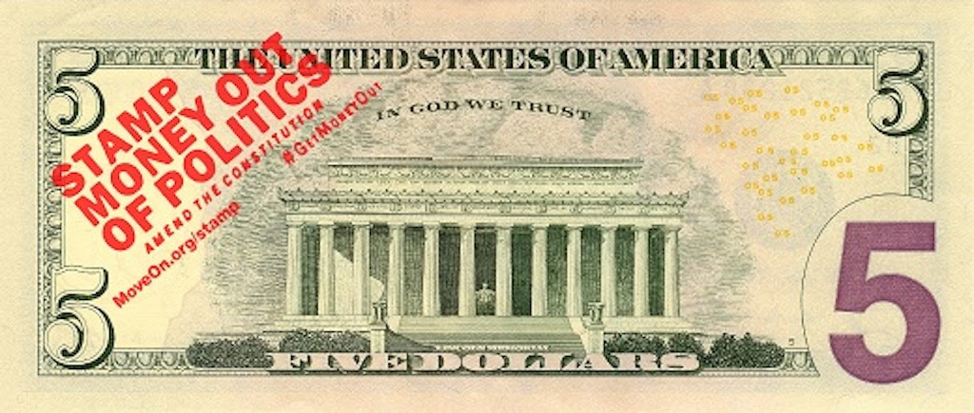](https://act.moveon.org/donate/stamp-stampede-2018?suggested_ask=25&product_265=1&prefill=1&t=15&akid=196514%2E1195276%2EWZC5JK)  
  
[**Click here to get your stamp, help stamp money out of politics, and be entered to win a year's supply of free ice cream!**](https://act.moveon.org/donate/stamp-stampede-2018?suggested_ask=25&product_265=1&prefill=1&t=16&akid=196514%2E1195276%2EWZC5JK) https://act.moveon.org/o.gif?akid=196514.1195276.WZC5JK

**Want to support MoveOn's work without getting a stamp?** The MoveOn community will work every moment, day by day and year by year, to resist Trump's agenda, contain the damage, defeat hate with love, and begin the process of swinging the nation's pendulum back toward sanity, decency, and the kind of future that we must never give up on. And to do it we need your ongoing support, now more than ever. **Will you stand with MoveOn?**[Donate monthly](https://act.moveon.org/donate/pac-donation-footer?payment_hash=7k472otg.201801050228.hzow5bh7.V_mWm0xxem&donation_type=recurring&source=mailing-footer&t=9&akid=196514%2E1195276%2EWZC5JK) or [make a one-time gift](https://act.moveon.org/donate/pac-donation-footer?payment_hash=7k472otg.201801050228.hzow5bh7.V_mWm0xxem&source=mailing-footer&t=10&akid=196514%2E1195276%2EWZC5JK)  
  
No purchase, payment, or contribution necessary to enter to win. Void where prohibited. Entries must be received by 11:59 p.m. on January 18, 2018. You may [enter by making a donation here](https://act.moveon.org/donate/stamp-stampede-2018/?t=17&akid=196514%2E1195276%2EWZC5JK). Alternatively, you can [enter without making a donation](https://act.moveon.org/survey/win-years-supply-ben-jerrys-ice-cream-2018/?t=18&akid=196514%2E1195276%2EWZC5JK). One winner will receive the following prize package: coupons for 52 pints of Ben & Jerry's Ice Cream (approximate retail value: $234). Odds of winning depend on number of eligible entries received. Promotion open to all U.S. citizens, or lawful permanent U.S. residents who are legal residents of the 50 United States and District of Columbia and 18 or older (or of majority under applicable law). Promotion subject to [Official Rules and additional restrictions on eligibility.](https://act.moveon.org/survey/official-rules-stamp-stampede-contest-2018/?t=19&akid=196514%2E1195276%2EWZC5JK) Sponsor: MoveOn.org Political Action, 1442 Walnut Street #358, Berkeley, CA 94709.  
  
Contributions to MoveOn.org Political Action are not tax deductible as charitable contributions for federal income tax purposes. PAID FOR BY MOVEON.ORG POLITICAL ACTION, <http://pol.moveon.org/?t=20&akid=196514%2E1195276%2EWZC5JK>. Not authorized by any candidate or candidate's committee.

**From:** Judy Burnette   
**Subject:** "What do you call somebody who supports Israel?" | Veterans Today  
  
<https://www.veteranstoday.com/2018/01/03/what-do-you-call-somebody-who-supports-israel/?utm_source=Jan.+04+2018&utm_campaign=VT+Newsletter&utm_medium=email>

**From:** LinkedIn  
**Subject:** When it's okay to quit your new job

**When it's okay to quit your new job  
  
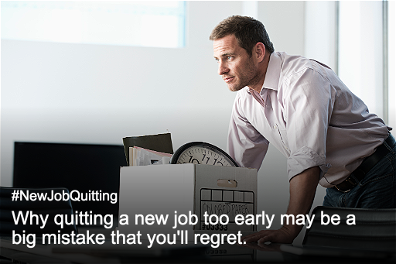**104 people are talking about this

End of MPEN e-Newsletter